
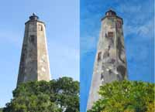
REGISTRATION for 2-DAY WORKSHOP

with Susan Brubaker Knapp:
“Wholecloth Painting from Original Photos”

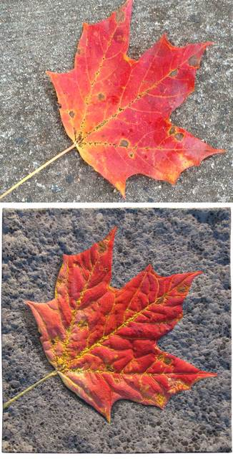
Learn the basics of painting on fabric to make wholecloth painted quilts. Students start by tracing their photo to create a pattern, transfer their pattern to fabric, and then use acrylic textile paints to recreate them on fabric. Students can begin one – or sometimes two – projects during the two-day class. They will learn how to select the right photos for great results; how to mix colors, shades and tints; and how to choose paints and fabrics that work for this technique. We will also cover how to thread sketch and/or quilt the projects at home.
Students are encouraged to send their photos to Susan in advance, to ensure that they will work for this class. (NOTE: no machine work)

April 9 & 10, 2025 (Wednesday & Thursday)
Arrival/Check-in/Set-up from 9.00 am to 9:30 am
Workshop starts at 9:30 am
Blacksburg Presbyterian Church, 701 Church St. SE, Blacksburg, VA 24060

$140 member (TAVA) full workshop fee per person
$160 non-member full workshop fee per person

For more images, info, and supply list go to: https://textileartva.wixsite.com/tava/workshops

Mail the form below with a check payable to “TAVA (Textile Artists of Virginia)”:
Karin Tauber, 6104 Albemarle Lane, Blacksburg, VA 24060

Questions? Please contact Marietta Nester marietta.price@gmail.com 540-769-7874

A confirmation email will be sent to you upon receipt of your registration and full payment.
If you have not received an email confirmation within 2 weeks, please contact Marietta to verify your information.

Refund policy: The workshop fee is non-refundable. In the event that you are no longer able to attend, you may find someone else to take your place at the workshop. Please contact Marietta about any changes.

-----------------------------------------------Copy by machine or hand and detach ----------------------------------------------------

Registration: “Wholecloth Painting from Original Photos” with Susan Brubaker Knapp
April 9 & 10, 2025 in Blacksburg, VA

Contact information (Please print clearly)

Name__________________________________ Preferred first name for nametag:__________________________

Street________________________________________ City____________________________ Zip_____________

Email_________________________________________ Phone (_______)_________________________________

Member (TAVA) workshop fee per person: $140 (Make check payable to TAVA)
Non-member workshop fee per person: $160 $_____________

