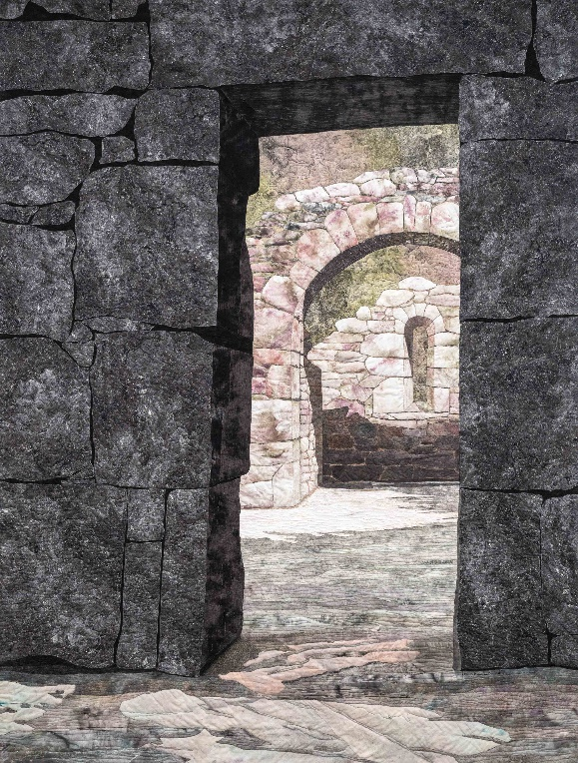

**Denise Labadie**

**“Stone Portraits and Stonescapes”**

**November 17, 2024 – 1.30 pm**

**Lecture: Zoom Presentation**

**Denise makes art quilts of megalithic stones, monoliths, and centuries old monastic ruins. Drawing on what is now a portfolio of nearly sixty "stone portraits", Denise will discuss her development of both a recognizable style and self-identifying "story", and her evolving adoption, use, and "tweaking" of select art quilt composition and construction techniques (including fabric painting) and “best practices”. This lecture is sponsored by TAVA.**

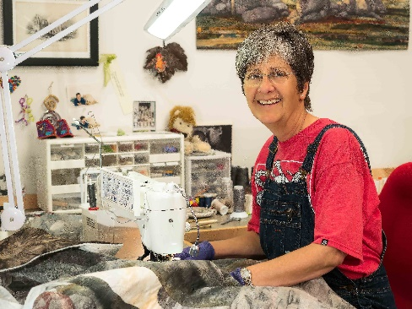

**Topics also include:**

– **telling the stones’ stories through her art**

**– how she constructs her stone structures and landscapes**

**– her management and control of color, texture, & dimensionality**

**– her struggles relative to perspective, depth, and shadowing**

**– the critical role of craftsmanship and art fundamentals in**

**creative expression**

Free to TAVA members.

**$10 for non-members**

* Non-Members will be sent a link upon receipt of payment
* Contact [gail.billingsley@gmail.com](mailto:gail.billingsley@gmail.com) if you have not received link after 10 days

Full info at <https://textileartva.wixsite.com/tava/lectures>

--------------------------------------------------------------------Detach & Mail--------------------------------------------------------------

**Registration for Zoom Lecture:**

**“Stone Portraits and Stonescapes” by Denise Labadie on November 17, 2024, 1.30 pm**

**Contact information (Please print clearly)**

Name_________________________________________________________________________

Email _________________________________ Phone Nr________________________________

**Lecture fee per person: $10 (Check payable to Textile Artists of Virginia) $ _____________**

**Deadline is November 2 to mail registration and check** to:

Gail Billingsley, 1849 St. Andrews Circle, Blacksburg, VA  24060